Observers: T. Lavictoire Survey Results: No Detection
Mountain Range: Chiricahua
Quad map name(s): Portal, AZ General Habitat: Mixed Conifer and Cliffs
Visit#: DS1
Sunrise or Sunset Time: 0627
Times For: | Start (24-hr) | End (24-hr) | Total  (~ ¼ hour)
Hike-in: | 0526 | 0548 | 0.25
Survey: | 0548 | 0630 | 0.75
Hike-out: | 0630 | 0720 | 0.75
Weather: | Survey
Weather: | Start | End
Wind (range mph): | 0-5 | 0-5
Clouds (%): | 0 | 0
Precip: | None | None
Temp (F): | 48 | 51

Mexican Spotted Owl Locations are reported in table below
 |  |  | Response |  | NAD83
SPP | Sex | Age | Type | Time | UTM-E | UTM-N
Use the following codes:
SPP = STOC for Mex Spotted Owl
Sex: F = female, M = male, U = unknown
Age: A = adult, S = subadult, Y = branched
young; H = hatchling or nestling
Response Type: V = seen, A = heard,
N = none, NEST = Nest found,
D = dead owl found
Time = 24 hr time of response

Mousing Used? N Number Used:

I = Ignores;
 | Fates of Mice Initially Taken By The
Mouse # | Male | Female | Unknown
1:
2:
3:
4:
5:
6:
C = cached;
F = given to female out of nest;
M = given to male;
Y = given to young;
N = taken to nest or to female in a nest;
A = eaten by individual that took the mouse;
L = left with mouse and fate unknown;
G = mouse got away;
H = held for 1 hour.

Nest located? N Evidence used: Day roost located? N

Other raptors seen or heard during survey:

Comments:

I parked my vehicle near the entrance of a USFS facility UTM location (NAD 83): 672085 E, 3528863 N and began hiking (see START/END and blue route on map) an hour before sunrise. I attempted to locate the male that responded the previous night (see PT1 on map). I surveyed the area in near perfect weather conditions from 0548 to 0630 but didn’t get any response. Judging by the short distance between the 2012 Sceloporus Nest/Roost area and where the male was heard last night, it is likely that the male who responded during NS1 is the Sceloporus male.

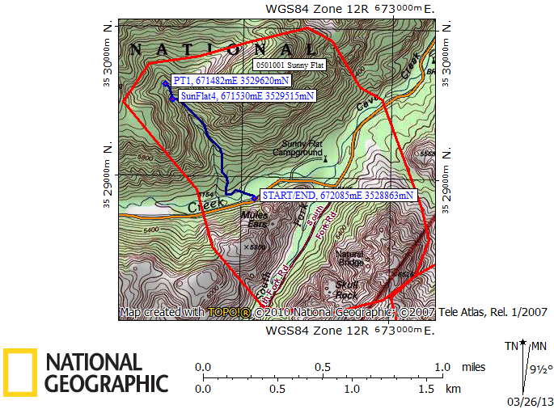

Red line = PAC boundary Blue line = path hiked

